Race Registration Form
Run Information: (Check event entered)
[ ] 5K Run/Walk ($22) [ ] 1 Mile Fun Run/Walk $8)

Shirt Size: (Check One)
[ ] S [ ] M [ ] L [ ] X L
Long sleeve T-Shirts to the first 300 pre-registrants
(Shirt not included for Fun Run/Walk participants).

Runner’s Information:

Last Name: _______________________________
First Name: _______________________________
[ ] Male [ ] Female Age on Race Day: ______
Address: _________________________________
City: ____________________State: __________
Zip: _______ email: ______________________
In consideration of your permitting me to participate in this event, on behalf of myself, my heirs, executors, administrators, successors and assigns, I hereby waive and release all rights and claims for damages which I may have against you or your assigns, the municipalities in which the event occurs, or anyone connected with the event, their heirs, executors, administrators, successors, and assigns, for any and all injuries or illnesses which I may suffer as a result of taking part in the event. I grant my permission to use my name or any audio or visual recording for any lawful purpose.

NOTE: Volunteers will be on hand to guide participants, but roads will be open to traffic.

I have read & understand the above waiver.
Signature: ________________________________
Date: _________________
Parent’s Signature if under 18 years of age:
___________________________ Date:__________
Please mail completed form by Oct. 18th, w/ payment to:

Fitzy’s Run, c/o A Running Start
705 Penn Ave.
West Reading, PA 19611

Make checks payable to “The Lauren Fitzgerald Fund”

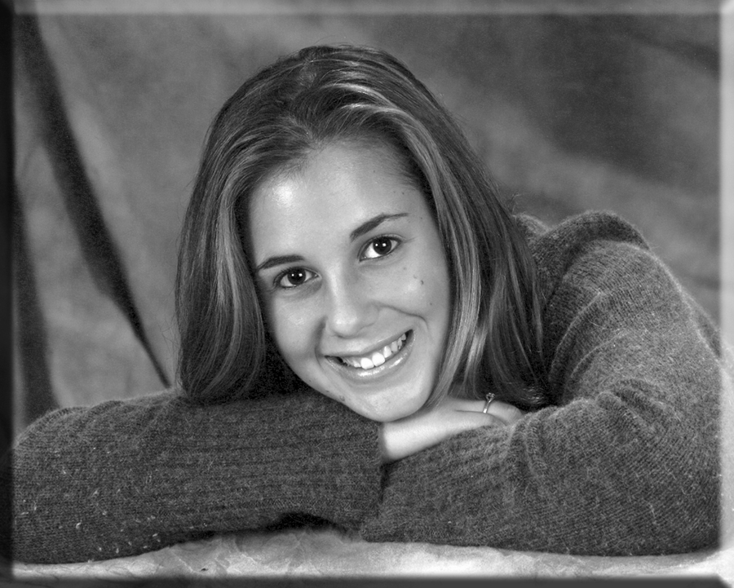
Lauren “Fitzy” Fitzgerald

October 31, 1984 – July 18, 2005

Lauren’s Story

Lauren Fitzgerald was a life-long resident of Berks County, PA. She attended Wyomissing Area Schools, graduating with honors in June, 2003. Lauren then enrolled at Drexel University in Philadelphia, where she majored in interior design.

In May, 2004, while a freshman student at Drexel, Lauren was diagnosed with a primary brain tumor. She underwent 2 surgeries that summer, followed by chemotherapy treatments and other regimens. In May, 2005, the tumor grew back aggressively. A scheduled 3rd surgery was canceled. Lauren died on July 18, 2005, at Duke University Hospital, after lapsing into a coma, at age 20.

Throughout her 14 month ordeal, Lauren maintained her dignity, her love of life, and her high spirits. She refused to let her diagnosis interfere with her life, choosing instead to live by a favorite quote from poet Maya Angelou: “I may not be able to change what happens to me. I refuse to be reduced by it.”

Even death could not diminish her love of life. Five (5) people received the gift of life because Lauren chose to donate her organs – her heart, lungs, liver and kidneys were used to serve those in need. Her legacy, love and generosity will live forever.

Fitzy’s Run

“A Step in the Right Direction”

4th Annual Halloween Family Event Featuring:

5K Run/Walk
1 Mile Fun Run/Walk

Costume contest, face painting, raffle, refreshments & more!

Sunday, October 26, 2008

11:00 am

Happy Hollow Playground
Wyomissing, PA

Benefiting brain tumor research & local scholarships in memory of Lauren Fitzgerald
Rain or Shine Event

Happy Hollow Playground
Terrace & Trent Avenues

Wyomissing, PA

Pre-Registration
Deadline: by October 18th
$22 for 5K Run/Walk (incl. long-sleeve T-shirt!)
$8 for 1 Mile Fun Run/Walk (shirt not included)

Pre-registration packet pick-up available on Friday & Saturday, October 24th & 25th at
A Running Start!

Reg. after Oct 18th
Including day of race
$26 for 5K Run/Walk (T-shirts while they last)
$10 for 1 Mile Fun Run/Walk (no T-shirt)

Race Day Registration begins at 9:30 am at Happy Hollow Playground Pavilion
AWARDS will be given to the top three (3) male
and top three (3) female finishers, and the top
three (3) finishers in each of the following age groups, both male and female: U15, 16-19, 20-24, 25-29, 30-34, 35-39, 40-44, 45-49, 50-59, 60-69, 70 and over.

Costume Judging Contest

for both 5K and 1 Mile

events! (costumes optional)

Post Run/Walk Buffet

Grilled dogs, burgers, salads,
snacks and beverages for all!

Race Sponsor:

705 Penn Avenue, West Reading, PA 19611

Additional registration forms are available at
www.arunningstart.biz
Race Questions : Call XXX-XXX or xyz@net o
Directions to Happy Hollow Playground
The playground is located approx. 6 blocks from
the Vanity Fair (VF) outlets in Wyomissing, PA. It is bordered by Terrace, Lynne, Trent & Garfield Aves.
1. From points east: Follow Rt. 422 WEST to Reading. A: Take Penn Ave. WEST exit, to West Reading. Follow Penn Ave. (west) for approx. 1 mile to 7th traffic light at Reading Blvd. Turn left onto Reading Blvd. B: Travel .2 miles to stop sign. Turn right onto Wayne Avenue. Playground is one block ahead, at Wayne and Trent Avenues.
2. From points west: Follow Penn Ave, (aka Rt. 422 business) toward Reading / West Reading. In Wyomissing, turn right onto Reading Blvd. (approx. 1.2 mi. from Rt. 222 overpass) Follow B above.

3. From points north: Take Rt. 222 South toward Reading. Follow A & B above.
4. From points south: Follow Rt. 222 North toward Reading. Take Penn Avenue EAST (business) exit. At bottom of ramp, turn right onto Penn Avenue east. Follow for approx. 1.2 miles to Reading Ave. and turn right. Follow B above.

Parking:
Street parking is available on Terrace, Trent, Wayne, Garfield, Lynne Avenues and surrounding roads.
Reading Blvd
Trent
Lynne
Wyomissing Blvd.
Wayne
Terrace
Garfield
Reading Blvd.

Happy Hollow
Playground

Fairview
Belmont
www.bt-family.org/lauren/lauren.htm

Penn Ave (Rt. 422 Business)
Bern Rd.
Laser The Works Gold’s
Quest Gym
Gym
Wyo. Post Office
to W. Reading
to West Lawn
About The American
Brain Tumor Association

Founded in 1973 out of a desperate need, the American Brain Tumor Association (ABTA) exists to eliminate brain tumors through research and to meet the needs of brain tumor patients and their families.

As a nonprofit organization, the ABTA relies on charitable donations to fund research and patient services. They do not charge patients for materials; they do not receive federal funding or support.

For more information about ABTA visit:

www.abta.org.
About the Lauren Fitzgerald Scholarship Fund

The Lauren Fitzgerald Scholarship Fund was created to provide financial assistance to high school seniors that, like Lauren, have excelled academically despite personal challenges and adverse circumstances in their lives – and choose to continue their education at an accredited college, university or trade school. To date, over $10,000 in scholarships have been awarded to deserving high school seniors.

For more information, visit:

Proceeds from this event will be donated to the ABTA through the Lauren Fitzgerald Fund for Brain Tumor Research and to the Lauren Fitzgerald Scholarship Fund benefiting local students. Lauren’s funds are managed by the Berks County Community Foundation (BCCF), an approved 501(c)(3) non-profit organization.

