Please Print – Entry Form – One Per Person
Last Name ______________________________ First Name ______________ Male Female
Address________________________________________City/State/Zip____________________ Family/Team Name ____________________Date of Birth __________ Age on race day_______ Email:________________________________________Phone ___________________
Registering for: 5K Run2 Mile Walk Adult T-shirt Size S M L XL XXL Child L
Fee Enclosed $______________ (Checks payable to the Hatboro YMCA) Register on-line and Save!
Please send me information on YMCA Membership Y N WWW.YMCAHATBORO.ORG
Waiver and Release: I, the undersigned (over age 8) intending to be legally bound, do hereby waive and release all rights, claims, demands, and/or causes against the Hatboro YMCA and all other race sponsors for an personal injury which I might sustain during the race, immediately known to me or hereafter discovered and for any and all other damages to losses which I might incur now or in the future arising from or out of my participation in this race, and on my travel to and from this race. I verify that I am physically fit and have trained sufficiently. Permission is granted to use my photograph and name for any and all purposes.
Signature: ____________________________________________ Date: _____________
(If under the age of 18, a parent or guardian’s signature is required.)


Description
- Professionally timed 5K run
- Accurately measured course
- Beautiful Course through Hatboro and surrounding neighborhoods, starting and finishing at Pennypack Elementary School
- 2 Mile Walk is timed, non-competitive
- Families, strollers and all ages welcomed!
- Halloween costumes encouraged

Visit www.ymcahatboro.org for course maps and directions to the start

Race Amenities
- Grover Silcox is your host
- Long Sleeve T to first 400 reg. 5k’s
- Run “goody” bag
- Post-event refreshments
- Free raffle
- Professional Timing
- Free Children’s Supervised Activities (age 3 and up)
- Moon Bounce
- Entertainment and DJ
- Post-race shower available at the YMCA

Awards
- OVERALL MALE AND FEMALE (5K) TOP 3
- AGE GROUP AWARDS 1st, 2nd, 3rd
U13, teens, 20’s, 30’s, 40’s, 50’s, 60+
- *COSTUME PRIZES:
Best Costume-Adult and Child
Scariest Costume
Best Family/Group Costumes

Entry Fees (Run or Walk)

Pre-registration by Oct. 12th
ON-LINE
$16 ADULTS (plus proc. fee)
$8 CHILDREN UNDER 12 (plus proc. fee)

MAIL IN OR DROP-OFF
$18 ADULTS
Received by Friday, Oct. 26
Hatboro Area YMCA
440 S. York Road
Hatboro, PA 19040
$8 CHILDREN UNDER 12
10% Discount for pre-registered families or groups of 3 or more (mail in or drop off only)
ONLINE REGISTRATION
https://www.pretzelcitysports.com
(Nom. Serv. fee applies, closes at Midnight, the Wed. of race week.)

Registration After Oct. 12
Including Race Day
$22 ADULTS
$8 CHILDREN UNDER 12
Race Day Registration: 8am to 9:15am

Packet Pick-up at the Hatboro Y, 9am to 9pm, October 25 and 26.
Rain or Shine
Fees are not Refundable
Questions? Contact Gary Chamberlain
215-674-4545, ext. 1104 or gchamberlain@philaymca.org
Hatboro Area YMCA
440 South York Road
Hatboro, PA 19040

Second Annual

Main Street Hatboro and Hatboro Area YMCA



Saturday, Oct. 27, 2017
9:30AM START

5K Run and 2 Mile Walk
Long Sleeve T-Shirt
Free Raffle
Refreshments
Professionally Timed

Proceeds benefit
Hatboro Area YMCA Financial Assistance Program and

Main Street Hatboro
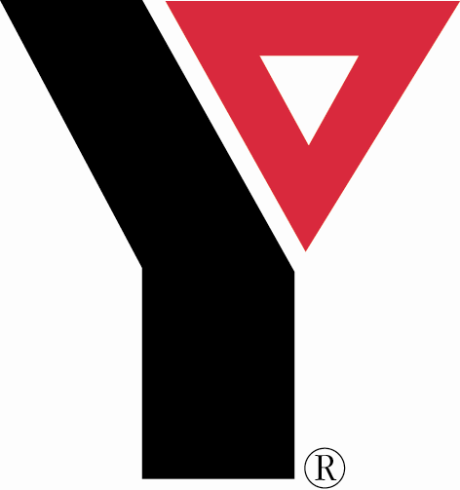

MAIN STREET
HATBORO

Please support our sponsors
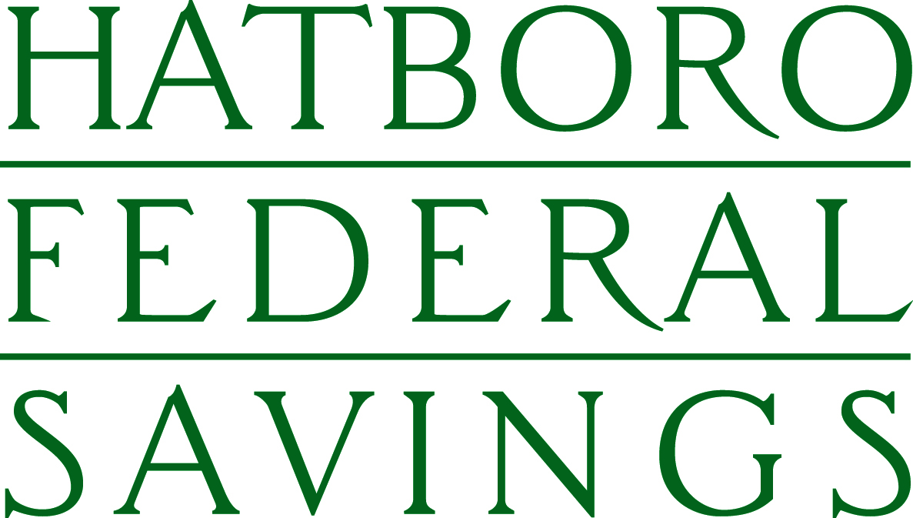

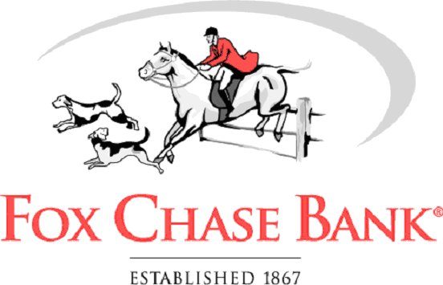


Celebrity Host & Media Personality

Grover Silcox
Visit www.ymcahatboro.org for directions and course maps.
Race will begin just down the road from the Hatboro Area YMCA at:
Pennypack Elementary School
Spring and Chester Avenues
Hatboro, PA 19040



