***Upper Bucks Foot and Ankle***

***Run for Youth***

***Supported by the Quakertown Rotary***

10 Mile & 4 Mile Races

**March 3rd 2018**

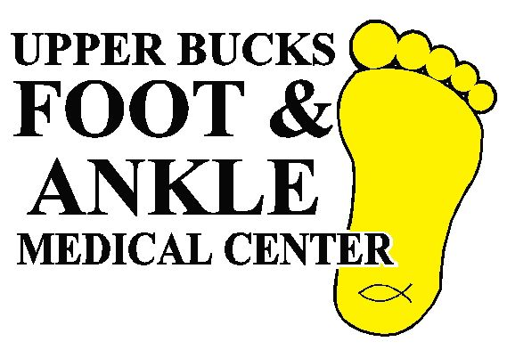

Pfaff Elementary School

1600 Sleepy Hollow Rd.

Quakertown PA 18951

Registration: 7:30-9:00AM

10 Mile Race: 9:00 AM

##### 4 Mile Race: 9:00 AM

Awards Follow each Race

**10 Mile Course is now USATF Certified #PA16002WB**

**Please Do Not Park on the Grass ! There is overflow parking at the Spinnerstown Inn & St. John's Lutheran Church.**

### Directions:

**From Route 309 (West End Blvd.):**

Turn west (right from southbound 309) at Route 663 (John Fries Highway). Go to the first traffic light after the PA Turnpike Interchange (Spinnerstown Rd.). Turn right and go to the four-way stop sign, Sleepy Hollow Rd., and turn left. The school is on your right just after the crest of the hill.

### From PA TPKE:

From the PA Turnpike, head west (right) on Rte. 663 (John Fries Highway) to the first light. Turn right and follow as above.

**From Reading:**

Take Rt. 73 East to Rt. 663 North. Follow Rt. 663 through Pennsburg to Spinnerstown Road. Turn left and follow as above.

**From Doylestown:**

Go west on Rt. 313 to Rt. 309. Continue straight as Rt. 313 turns into Rt. 663. Follow directions as above.

**GPS Coordinates:**

1600 Sleepy Hollow Road, Spinnerstown PA 18968

**Race organizer:**

**(Your Name and Phone Number)  
 (Your eMail Address)**

**March 3rd, 2018**

**Pfaff Elementary School**

**1600 Sleepy Hollow Rd.**

**Quakertown PA 18951**

**Registration: 7:30-9:00 AM**

**10 Mile Race: 9:00 AM**

##### 4 Mile Race: 9:00 AM

#### Awards Follow Each Race

Course Records:

10M – M: Matt Gilette – 54 (2014)

F: Crystal Burnick – 1:03:12 (2013)

4M – M: P. J. Meany – 20:14 (2011)

F: Lauretta Dezubay – 24:07 (2011)

Results will be posted at [www.pretzelcitysports.com](http://www.pretzelcitysports.com/)

**Photos posted at : Quakertown Rotary's Facebook page.**

**Awards (Male & Female)**

**4M:** Overall 1-3; 1st Masters, Age Group (3M/F): 14 & Under, 15-19, 20-29, 30-39, 40-49, 50-59, 60-69, 70+

**10M:** Overall 1-3; 1st Masters, Age Group (3M/F): 14 & Under, 15-19, 20-24, 25-29, 30-34, 35-39, 40-44, 45-49, 50-54, 55-59, 60-64, 65-69, 70+

**Quality Cotton Long Sleeve men & women cut shirts for all pre-registered runners and while supplies last on race day.**

**Timing services provided by Pretzel City Sports**

**In the event of bad weather, cancellation and rescheduling information will be posted on**

[**www.pretzelcitysports.com**](http://www.pretzelcitysports.com/) **& Quakertown Rotary's Facebook page**

***Note: Both races start together and share the first mile. Feel free to change your distance any time until the routes split, regardless of which distance you put on the registration.***

***Upper Bucks Foot and Ankle – Run for Youth Registration***

**Name** __________________________________________

**Address**  _________________

**City** _________________________ **State _____ Zip**

**E-Mail** ________  
  
**Phone:** ____________________ **Age on 3/2/18** ____________

***When choosing you event, feel free to change your distance during the race, any time until the routes split, regardless of which distance you choose below.*Event** : (Circle one) 10 Miler 4 Miler

**Shirt Cut** (Circle one) Male Female **Shirt size**: S M L XL

$35 Postmarked by 2/20/18 ________

$40 After 2/20/2018 & Race Day

Total Enclosed: $

**MAKE CHECK PAYABLE TO**:

Quakertown Rotary Club

**MAIL TO**: Your Organization & mailing address  
  
**Register online @ www.pretzelcitysports.com**

**I know that participating in a race is a potentially hazardous activity. I should not enter unless I am medically able to participate. I also assume any and all risks associated with participating in this event, including but not limited to falls, contact with other participants, the effects of the weather, traffic and the condition of the roads. In consideration of accepting this entry, I hereby waive for myself and my heirs all rights and claims for damages I may have against the Quakertown Rotary Club, and all other sponsors, volunteers, their agents or representatives arising out of, or in the course of, my participation in this event. I also give permission for the free use of my name and picture in any broadcast, telecast or print media account of this event.**

Signature

(parent/guardian if under 18 years)

Date________________

Join us for the Upper Bucks Foot and Ankle Run for Youth 10 Mile and 4 Mile races presented by the Quakertown Rotary. This challenging late winter 10 miler is a good test in advance of the spring race season while the 4 miler is a rolling out-and-back course for runners who prefer shorter distances. Both courses run through the rolling hills of Upper Bucks County and are well marked with signs and volunteers at all major intersections. While the roads are open, there is relatively little traffic.

Facilities include ample parking, indoor registration and awards and a generous post-race buffet featuring , grilled foods and fruit.

Founded in 1905, Rotary International is a service club dedicated to the ideal of “Service Above Self.” With Clubs in over 100 countries, there are more than one million Rotarian’s worldwide.

The Quakertown Rotary Club has been performing community service work since 1924. For more information about the Quakertown Rotary Club, visit the Club site at [www.quakertownrotary.org](http://www.quakertownrotary.org/).

Organizations supported by the Quakertown Rotary Club include the Upper Bucks YMCA, Children's Development Program, Habitat for Humanity of Bucks County, the Quakertown Historical Society and The Quakertown Parenting Center

The race proceeds fund a variety of youth programs. These include scholarships for deserving high school seniors and Student of the Month Awards at Quakertown High School. Quakertown Rotary also sponsors attendees at the Camp Neidig Leadership Training Camp and Pennsylvania Free Enterprise Week.