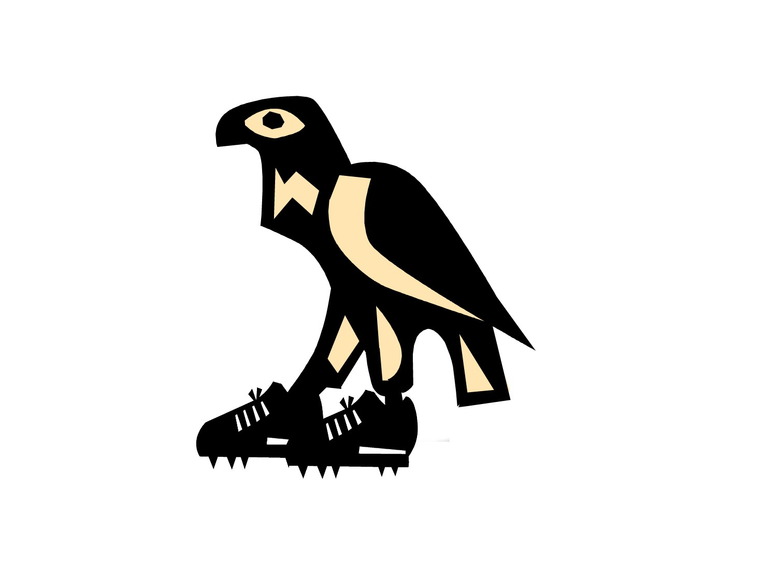
The Great Valley Nature Center Presents the 1^{rst} Annual

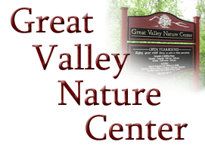
Marsh Creek

Raptor Run

5 Mile & 10 Mile Trail Races
Sunday, July 22, 2007- 9:00 A.M.
Marsh Creek State Park, Downingtown, PA

The Great Valley Nature Center was founded in 1974 as a non-profit organization dedicated to providing environmental education and recreation experiences for school children, organized groups and the general public.
Located on 10 ½ acres, the Nature Center provides educational experiences for over 40,000 people each year.

Proceeds from the race will help provide environmental education programs for special needs and underprivileged children, including camp scholarships, and support the Birds of Prey Center, a home for permanently injured raptors that have come in from various rehabilitation facilities.

SPONSORSHIP OPPORTUNITIES

EAGLE: Sponsorship Level: $1,000
- 4 inch by 4 inch logo or advertisement on Race T-shirt
- Special recognition on Race Program, Web Page, in GVNC newsletter and annual report
- A banner (provided by your company) or 20” by 30” sign will be produced and displayed at Race Pavilion
- Opportunity to set up a stand and Showcase products and services (selling not permitted by park)
- First opportunity to secure prime sponsorship level for 2008 race
- Receive 4 complimentary Race T-shirts showing sponsorship

HAWK: Sponsorship Level: $500
- 2 inch by 2 inch logo or advertisement on Race T-shirt
- Special recognition on Race Program and Web Page
- A banner (provided by your company) or 20” by 30” sign will be produced and displayed at Race Pavilion
- Receive 2 complimentary Race T-shirts showing sponsorship

OWL: Sponsorship Level: $100
- Organization name printed on Race T-shirt
- Special recognition on Web Page
- Receive 1 complimentary Race T-shirt showing sponsorship

For more information or to make a donation, please contact the Great Valley Nature Center at 610 935-9777 or www.gvnc.org or Matt Bogusch at 610 368 1236, or mattbogusch@yahoo.com

Also, Please visit our Raptor Run Race site at www.marshcreekrun.org

Great Valley Nature Center

Marsh Creek

Raptor Run

Contributor Form

Contribution:

_________ Eagle ($1000)

_________ Hawk ($500)

_________ Owl ($100)

_________ Merchandise donor/other

Company Name: ________________________________________________

Company Address: ______________________________________________
______________________________________________
______________________________________________
______________________________________________

Contact Person:
Name: __________________________________________________
Tel #: ____________________ e-mail ________________________

Program Listing to Read: __________________________________
(attach business card or ad copy) ______________________________________

T-Shirt to read (or email logo to www.gvnc.org):
____________________________________
____________________________________

