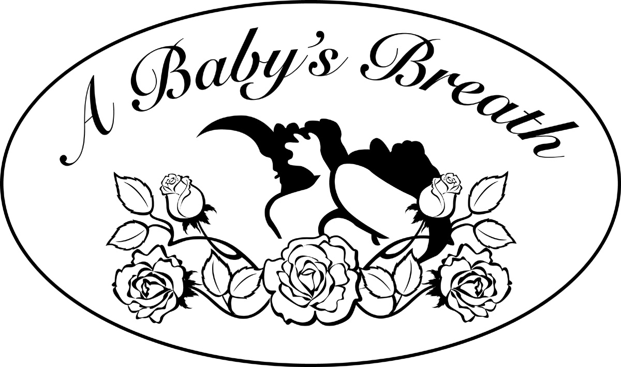
Board of Directors-St. Davids
Jennifer Volpe-Co-Director
Jack Toukatly –Co-Director
Paul Lavallee-Treasurer
Rosemary Friedrich-PR Chair Run-4-Life
Maria Colflesh-Run for Life Race Director
Christa Gartner – Parenting Class Coordinator
Juliet Najdawi – Setup Chairman

Board of Directors
Karen Patota – Founder & President
Vince Arena – Vice President
Joe Baldassari, Esq. –Secretary
Dorothy Swedkowski – Treasurer
Paul Burdett
Chris Custatis
Connie Edford
John Giorgis
Maryanne Gullick
Mark Hitchcock
Margaret Malloy
Anthony Re
Joseph Smith
Jack Toukatly
Jen Volpe

“… to help a mother see her child take his/her first breath.”

August 31, 2006

Via Hand Delivery
The Right Start

Dear Right Start:

We wanted to take this opportunity to inform you of the opening of A Baby’s Breath Crisis Pregnancy Center in St. David’s. Our center is run by volunteers, privately sponsored and operates as a 501C non-profit organization. We are in need of your help. We would also like to ask you to please consider sponsoring our Run for Life 2006 – St. David’s to benefit A Baby’s Breath – St. David’s. This race is our main fund raising event scheduled for November 5, 2006, with registration starting at 1:00 pm at Wilson Farm Park. No game is ever won by an individual and any assistance you can offer would be appreciated.

A Baby’s Breath offers free pregnancy tests, pregnancy counseling, pre-natal classes, parenting classes and material support. We provide a place where mothers, fathers, and families can workout the complications of a crisis pregnancy. Our volunteers are trained to work with clients in a compassionate, but objective way. For more information about our organization, please go to our website (www.ababysbreath.org).

Our sponsor levels are attached. Your financial support is greatly appreciated. You can reach me directly at (610) 710-1788.

Respectfully,

Maria Colflesh
Race Director
Run for Life 2006 – St. David’s
We have three levels of Run for Life 2006 - St. David’s Sponsorship:

- $1,000 – Gold – Name on the Run for Life 2006 – St. David’s T-shirt, full page advertisement in Run for Life 2006 – St. David’s brochure, on front of run sheet, corporate name in A Baby’s Breath December 2006 Newsletter & website (www.ababysbreath.org).

- $600 – Silver – Name on the Run for Life 2006 – St. David’s T-shirt, 1/2 page advertisement in Run for Life 2006 – St. David’s brochure, corporate name listed in A Baby’s Breath December 2006 newsletter and on website.

- $300 – Bronze – Name on Run for Life 2006 – St. David’s T-shirt, ¼ page advertisement in Run for Life 2006 – St. David’s brochure, corporate name listing in A Baby’s Breath December 2006 newsletter and website.

- Below $299 – Red Rose – Listing in brochure and in December 2006 newsletter.

Other sponsorship

- $100 - ½ page ad in Run for Life 2006 - St. David’s brochure

- $50 – ¼ page ad in Run for Life 2006 – St. David’s brochure

- $25 – business card ad in Run for Life 2006 – St. David’s brochure

- $100 Race Day (3X5 ft) banner

- $750 –A Baby’s Breath Newsletter sponsor – ½ page back cover advertisement

- $200 – ¼ page advertisement in A Baby’s Breath Newsletter

A Baby’s Breath Tax Identification Number (TIN# 23-3045525).

Please respond with your sponsors checked, your check to A Baby’s Breath, and your business card attached or e-mail your pdf/vector.eps file with advertisement/business card to help@ababysbreath.org ATTN: Maria Colflesh:

Name of Sponsor: __________________________________________________________

Address of Sponsor: ________________________________________________________

Phone: ______________________________________________________________

E-mail: ______________________________________________________________

